Appendix 13: Solution code
Scope. run_pipeline.py is the analysis pipeline the Brain and Mind Centre team would run for the go/no-go study (Validation 4). It is research software, not a certified medical device: it has been run end to end on a simulated cohort only, and must pass Validation 4 and the IEC 62304 / TGA steps (Section 8) before any clinical use. The verification code that tested its methods on real recordings is in Appendix 12D. Available at https://github.com/Vbaz2222/sleeping-minds-verification [N].
Inputs. One overnight PSG per person (EDF), an optional clinician hypnogram, and a spreadsheet of each person's anxiety label, age, sex, AHI, medication class and cognitive status (MCI/SCI). Lights-off and lights-on times are optional.
Command. python3 run_pipeline.py analyse --edf-dir data/ --clinical clinical.csv --out results/
Table 13.1. What each stage of the code does
Stage | What the code does | Main methods | Output
1. Feature extraction | Checks each file (EEG present, ≥ 4 h, ≥ 50 Hz) and stops with a clear message if it fails. Excludes EOG/EMG recorded below 50 Hz. Uses the clinician hypnogram if supplied, otherwise automated EEG + EOG staging with low-confidence epochs flagged. Keeps the main overnight sleep period (or lights-off to lights-on). Excludes epochs overlapping scored apnoeas. REM onset = first run of 3 consecutive REM epochs. | MNE, YASA, Welch power, NeuroKit2 | 11 sleep, spectral and heart-rate measures per person; quality record
2. Literature testing | Splits the cohort 70% training / 30% held-out. Tests each published biomarker against anxiety in the training set, adjusted for age, sex, AHI, medication and cognitive status. Features with FDR q < 0.10 are carried forward. | Mann–Whitney U, Hedges' g, adjusted logistic regression, Benjamini–Hochberg FDR | Table of effects; list of surviving biomarkers
3. Discovery | Learns latent sleep features from per-epoch EEG/EOG/EMG power without labels; uses PCA instead if the autoencoder does not rebuild unseen nights better. Groups people by their latent profile in N2, N3 and REM. | Autoencoder (32-6-32), PCA, k-means, silhouette score | Latent profile and group for each person
4. Validation of discoveries | Tests whether anxiety differs between groups in the training set, then checks the same group is over-represented in the held-out set. Only a replicated group is used in Stage 5. | Chi-square with 2,000-shuffle permutation p-value; one-sided Fisher exact test | Validated (or rejected) latent group
5. Classifier and decision | Fits elastic-net logistic regression on clinical factors plus surviving sleep features, and a clinical-only comparator. Sets the review threshold for ≥ 80% sensitivity on training data. Tests both on the held-out set and applies the Validation 4 go/no-go criteria. | Elastic net (C and L1/L2 mix by 5-fold CV), AUROC, DeLong test, bootstrap 95% intervals | GO / NO-GO decision; model file
Report | Writes one clinician report per person: probability with 95% interval, review threshold, the measures that drove it against the cohort range, hypnogram marking the two epochs that define REM latency, recording quality and a "Not a diagnosis" notice. | Matplotlib, HTML | report_<id>.html
Design changes from verification (Appendix 12C) built into the code: clinician-scored hypnograms used where available (12C item 3); channels below 50 Hz excluded and staging falls back to EEG + EOG (item 2); three-epoch REM onset rule (item 5); sleep efficiency from lights-off when supplied (item 6); main sleep period isolated (item 1).
Demonstration run. The pipeline was run end to end with python3 run_pipeline.py demo on 120 simulated people (84 training, 36 held-out) in whom longer sleep onset, longer REM latency and higher NREM beta power were planted as anxiety effects. All 120 recordings were processed, using all three hypnogram inputs and automated staging. Stage 2 recovered all three planted biomarkers (q < 0.01 for sleep onset latency and NREM beta; q = 0.08 for REM latency), plus one weak extra (REM eye-movement activity, q = 0.08). Stage 3 used the PCA fallback because the autoencoder did not rebuild unseen nights better. Stage 4 correctly rejected the discovered groups, since no group effect was planted (permutation p = 0.57). In Stage 5, adding sleep features raised held-out AUROC from 0.34 to 0.67 (DeLong p = 0.009), but sensitivity (64%) and specificity (55%) were below the 80% / 70% targets, so the pipeline returned NO-GO. This shows the decision rule working as specified: a statistically significant gain alone does not pass. These figures come from simulated data; they show the software working end to end and are not evidence about anxiety.
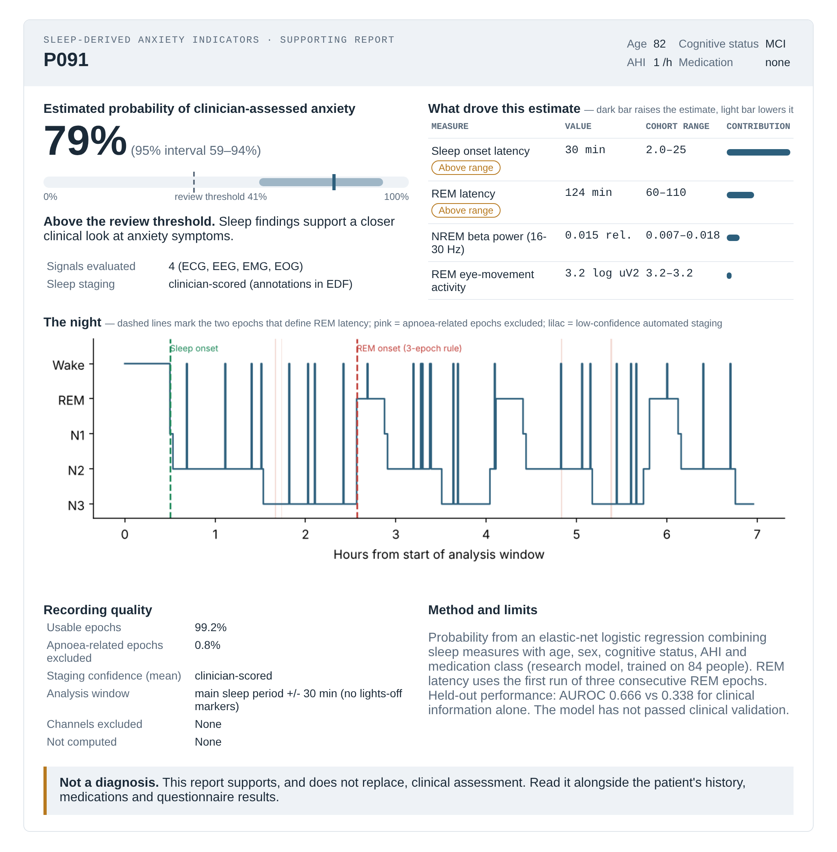
Figure 13.1. Example clinician report generated by run_pipeline.py for a simulated held-out participant.

